NADIA PEETERS, CPCC, ACC
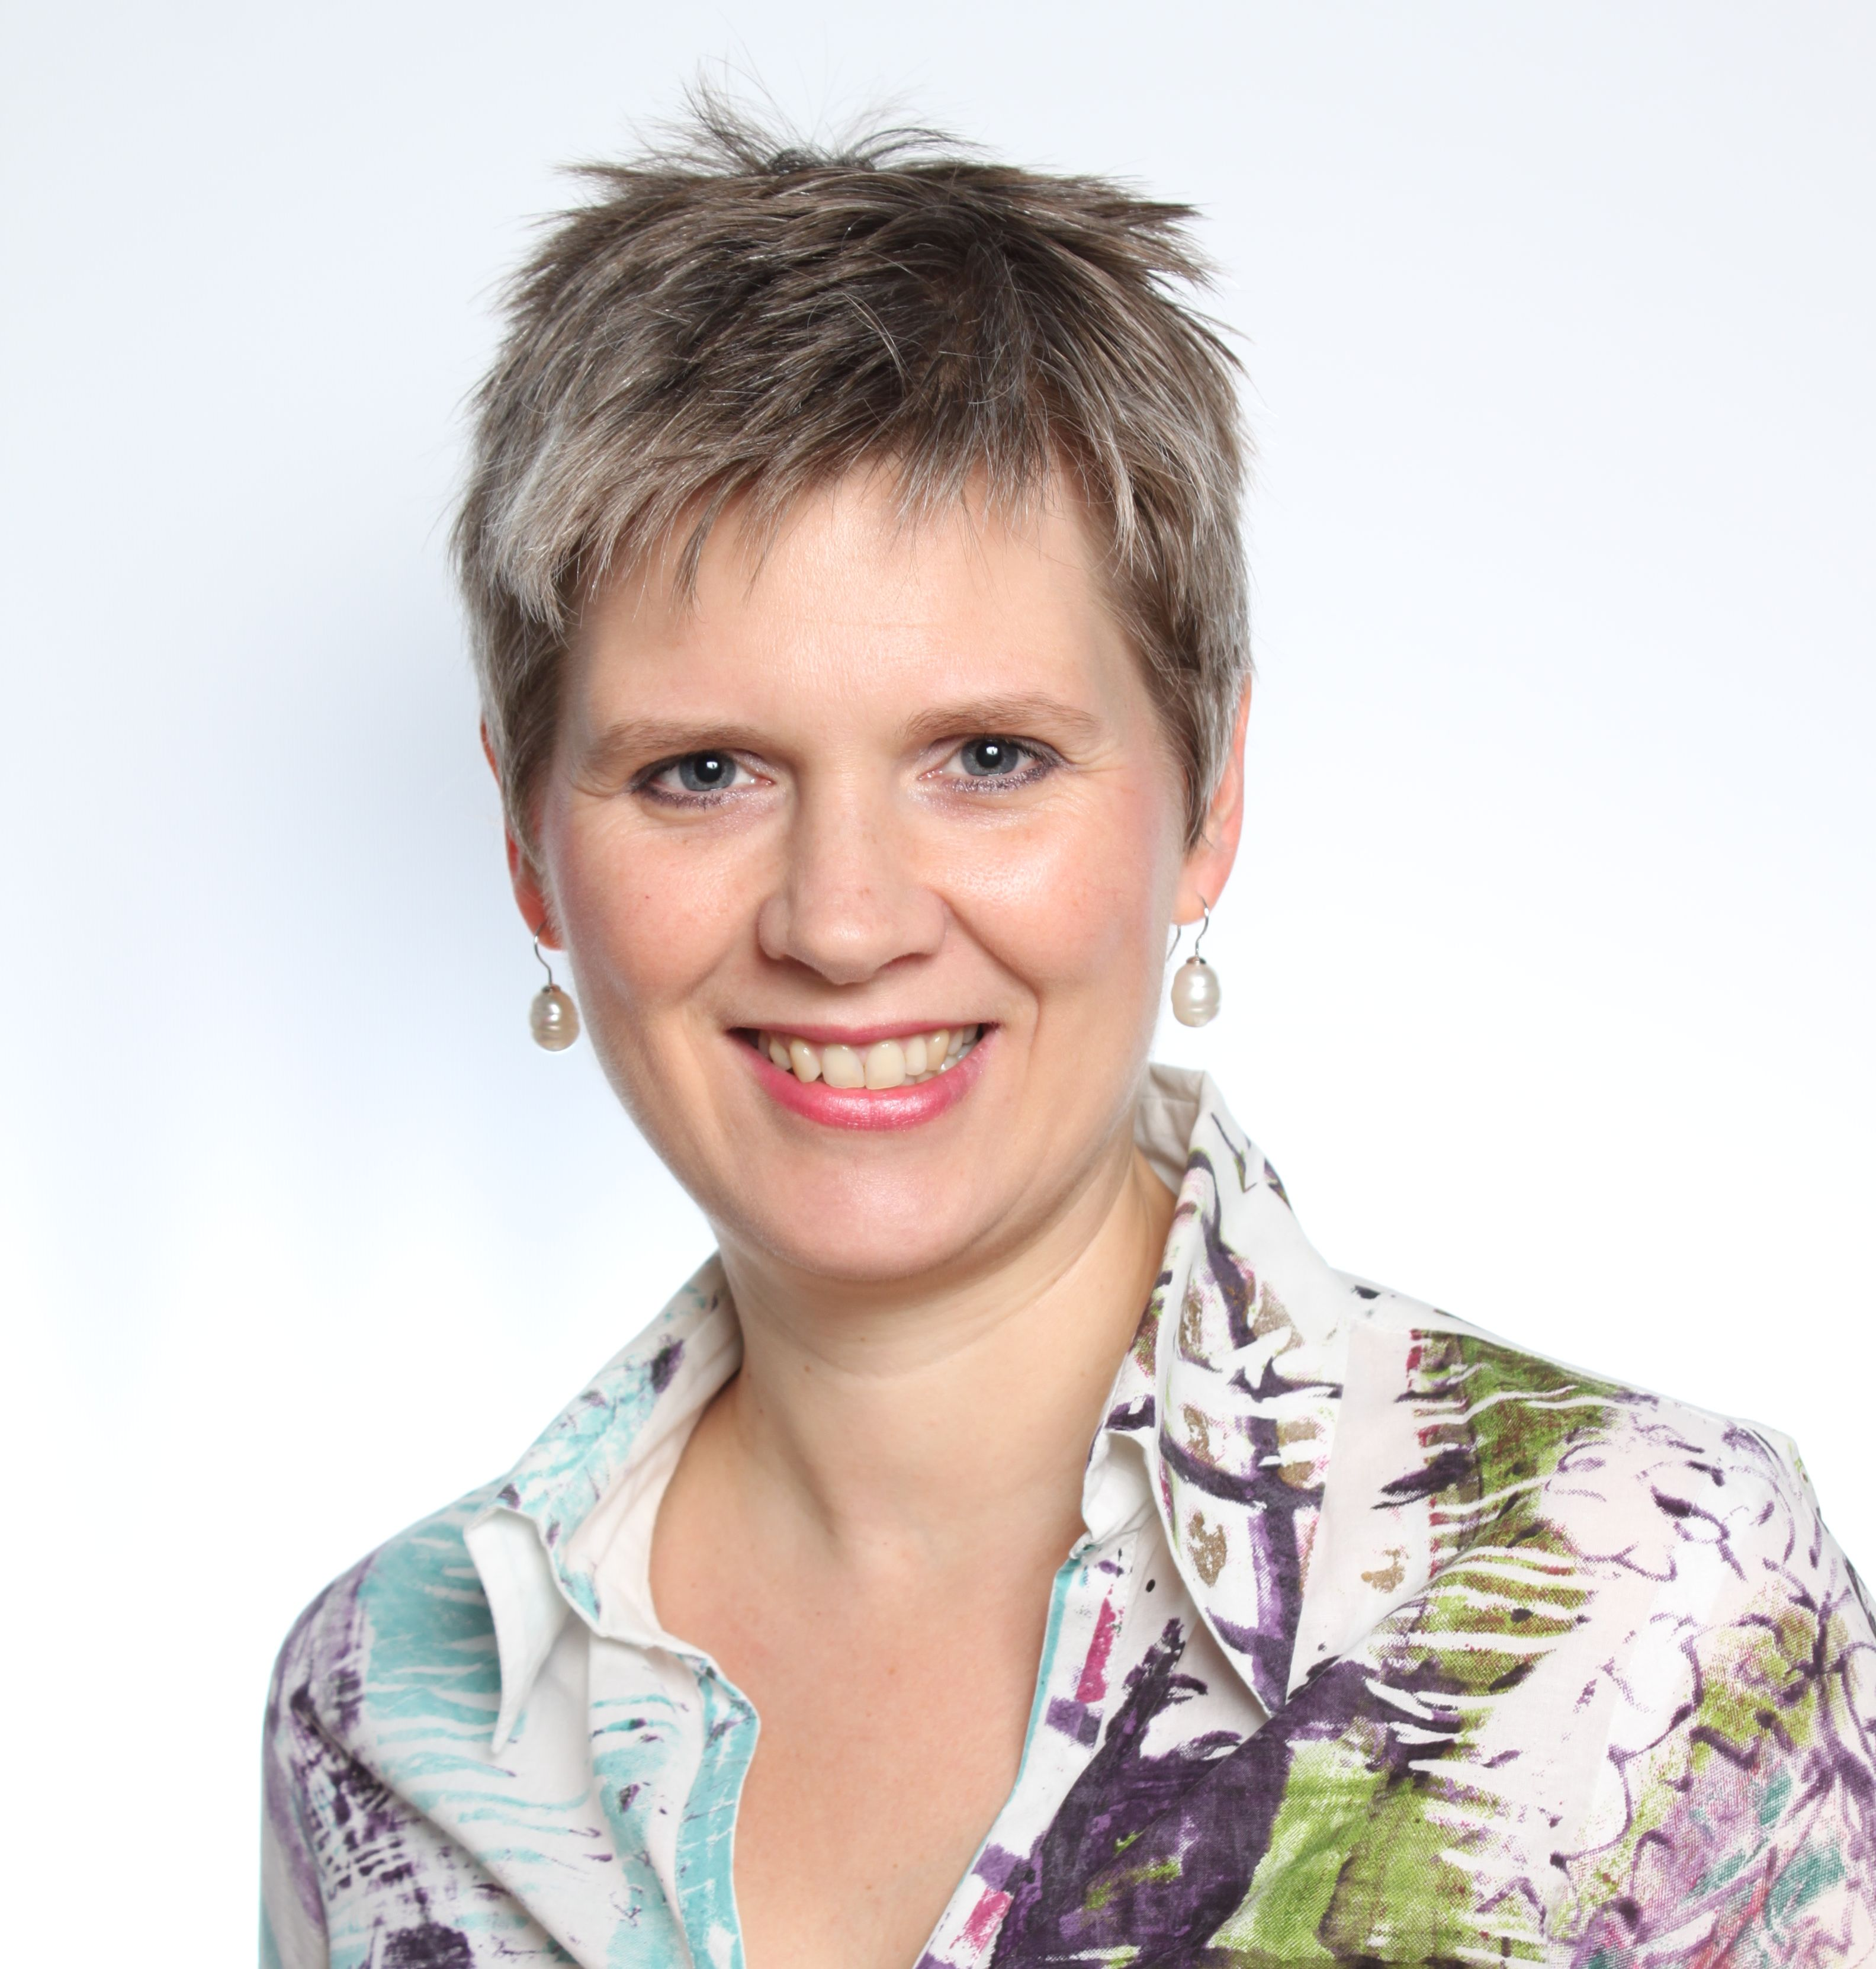
Calle Antracita 3, Portal C, 2º D
28045 Madrid - SPAIN
Phone: +34 663 395 384 / +34 91 649 42 20
Email: nadia@papayacoaching.com / nadia_peeters@hotmail.com

HIGHLIGHTS OF QUALIFICATIONS
• Strong organizational capabilities • A gifted mentor and coach
• A natural explorer and pioneer • Strategic, visionary and analytical
• Results-oriented leader • Professional and dedicated
• Multi-lingual and culturally sensitive • Exceptional interpersonal skills
• Straightforward, honest and fair • Committed to people

EMPLOYMENT HISTORY AND ACCOMPLISHMENTS

Professional Coach, Spain (Jan 08 – present)
Executive and Team Coaching, Coach Training Design. Coach Training.
Executive and Team Coaching in various companies and organizations, with clients in Spain, Europe, the Balkan and Central America focusing on creating more positivity and productivity in leaders and teams. Coaching clients: Telefonica España, Enagas, Thales, Australian Defense Dept, World Vision International, Habitat for Humanity, etc
Co-author of the new Dialogical Coaching Model with the Institute for Integral Executive Development (IDDI) at the Universidad Francisco de Vitoria, and co-designer, trainer and mentor-coach of the Certified Program in Dialogical Coaching. Member of the Executive Coaches Team of IESE Business School. Member of Augere´s Coaches and Experts Pool, and coach specialized in cross cultural coaching at the Global Coaches Network. Member of the International Coach Federation (ICF). Certified by ICF (ACC) and CTI (CPCC).
Number of coaching hours: 500
World Vision, Spain and Costa Rica (Jan 01 – Dec 08)
World Vision is an international humanitarian organization working with empoverished communities in sustainable development, humanitarian aid and advocacy in over 100 countries.
Country Director, World Vision Spain (Dec 03 – Dec 08)
Founded and led the new advocacy and fundraising office in Spain, growing the organization from 3 to 11 staff, with 10.000 child sponsors and a diversified income from child sponsorship, government and private grants, supporting 10 development projects in 7 countries, and a solid reputation within the sector and government. Contributed to international audit processes reviewing governance structures and alignment with organizational standards.

Customer Relations Service Manager, World Vision Costa Rica (Jan 01 – Nov 03)
Team leader of the Customer Relations Service unit in the field office that monitors the children registered in the sponsorship program, their participation in the sustainable development activities and how its impact is effectively communicated to the donors. Developed and implemented quality strategies to improve donor satisfaction and meet organizational standards, engaging project facilitators, community volunteers and parents. Member of strategy development team.

PMP Technical Documentation BV, Netherlands (Jun 99 – Mar 00)
Project manager; coordinated multi-lingual translation projects for medical technical documentation; selection and steering of translators and related DTP work; development of terminology quality procedures.

Medtronic BV, Netherlands (Aug 96 – May 99)
Project coordinator; coordinated multi-lingual translation projects for medical technical documentation and software. Launched department´s new translation and quality procedures.

European Parliament, Luxembourg (Jan 96 – Jun 96)
Intern in the Dutch translation department; translated European Parliament documentation from English, Swedish, Danish and French into Dutch.

ACADEMIC & PROFESSIONAL STUDIES
Sept 90 – Jun 94 BA Hons in Germanic Languages: Scandinavian and English literature and linguistics, University of Ghent (Belgium); graduated Magna Cum Laude.
Jan 93 – Jun 93 ERASMUS exchange student, University of Gothenburg, Sweden
March 06 Transformational Coaching, Institut Gestalt de Barcelona, Madrid
Jan 07 – Jun 07 Human Resources Management in NGOs, Agora Social, Madrid
Oct 07 Coach Training – The Coachville System, The International School of Coaching (TISOC), Madrid
Jan 08 – Jun 08 Co-active Coaching Program, The Coaches Training Institute, Madrid
Jan 09 – Jul 09 Co-active Coaching Certification Program, The Coaches Training Institute
Nov 09 – Jul 10 Organizational and Relationship Systems Coaching, Center for Right Relationship, Madrid, Spain
Mar – Jun 2012 Masterclass: International Coaching Masters: John Whitmore, Robert Dilts, Jim Selman, IDDI, University Fransisco de Vitoria, Spain

LANGUAGES
Dutch: native speaker
English/Spanish/German: fluent
French/Swedish: moderate

PERSONAL
Nadia is married to a Spaniard and mother of a young son. A true pioneer, all the times she was challenged to adapt to new situations have taught her that one can always achieve one´s goals with humility, courage and determination.

